Algebra 1B Name: _____________________________
Core Concepts Checkpoint PRACTICE
Concepts 1.1-5.2
Concept 1.1
Directions: Fully simplify the following expressions.
$4+2(3x−5)$ $6+2⋅3−8$ $3(x+2y)−(4x+2y)$

_________________________ _________________________ _________________________

Concept 1.2
Directions: Evaluate the following expressions with the given values.
$x^{2}−5x+6$ when $x=2$ $2c^{3}−\text{10}$ when $c=−3$ $4+3a$ when $a=5$

_________________________ _________________________ _________________________

Concept 1.3
Directions: Solve the equation for the indicated variable.
$A=5r+3$ $y=3x−h$ $b+4c=5$

$r=$____________________ $x=$____________________ $b=$____________________

Concept 1.4
Directions: Solve the following equations.
$4x+7=\text{23}$ $2t+5=3t−\text{10}$ $2(y+4)−1=−9$

$x=$____________________ $t=$____________________ $y=$____________________

Concept 2.1
Directions: Calculate the slope of the lines with the given information.
Connects points (-2, 1) & (3, 2) Perpendicular to the slope $m=\frac{3}{2}$

slope = ____________________ slope = ____________________

Concept 2.2 slope = ____________________
Directions: Sketch the graphs of the following equations.
$y=−\frac{1}{2}x+3$ $6x+3y=\text{12}$ $y−3x=−5$
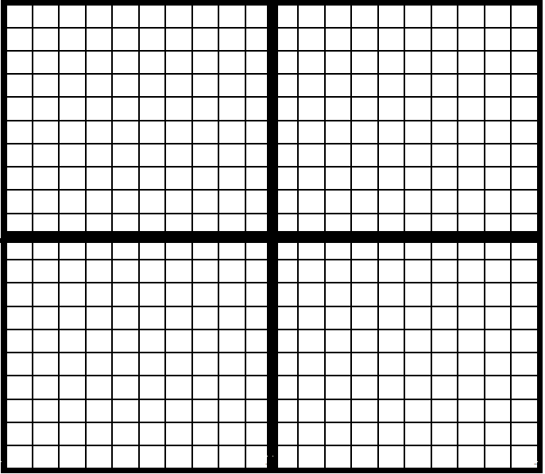

Concept 2.3
Directions: Write the equations of the lines in the indicated form.
$m=\frac{1}{2}$ and goes through (4, -1) $m=−3$ and $b=2$

_________________________ _________________________ _________________________
(Slope-Intercept Form) (Standard Form) (Slope-Intercept Form)

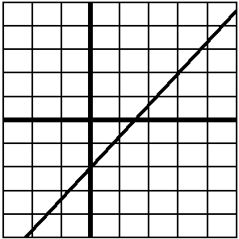
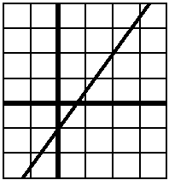
Concept 2.4
Directions: Determine whether the following represent functions or relations by circling your answer.

Directions: Given the function $f(x)=−2x^{2}−4x$ evaluate the following. $f(1)=$__________
Concept 2.5
Directions: Complete the following.
- Plot the data values on the graph:

Year (x) | TVs Sold (y)
2001 (1) | 3
2002 (2) | 5
2003 (3) | 4
2004 (4) | 7
2005 (5) | 8
2006 (6) | 7
2007 (7) | 9

- Draw the line of best fit

- Write the equation of the line in slope-intercept form: _________________________

Concept 3.1
Directions: Solve the following absolute value equations.
$|2x−3|=5$ $|3x|+6=9$ $|x−2|=−4$

$x=$_______________ $x=$_______________ $x=$_______________

Concept 3.2
Directions: Solve the following inequalities. Be sure to write your answer as an inequality, in interval notation,
and plot your solution on the provided number line.
$3x−2≤4$ $−2x+4>\text{12}$

Inequality Solution: ____________________ Inequality Solution: ____________________

Number Line: Number Line:

Interval Notation: ____________________ Interval Notation: ____________________

Concept 3.3
Directions: Solve the following absolute value inequalities. Be sure to write your answer as an inequality,
in interval notation, and plot your solution on the provided number line.
$\left|x−3\right|>7$ $\left|2x+6\right|≤4$

Inequality Solution: ____________________ Inequality Solution: ____________________

Number Line: Number Line:

Interval Notation: ____________________ Interval Notation: ____________________

x | 1 | 5 | 0 | 1 | 2 | 9
y | -5 | 7 | 8 | 9 | 0 | -2

Function Function

OR OR

Relation Relation
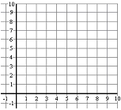
Concept 3.4
Directions: Sketch the graphs of the following inequalities.
Concept 3.5
Directions: Write the equations of the inequalities pictured on the graphs.

______________________ ______________________

Concept 4.1
Directions: Solve the following systems of equations by graphing.

Concept 4.2
Directions: Solve the following systems of inequalities by graphing.

Concept 4.3
Directions: Solve the following systems of equations by substitution or elimination (your choice!).

$\begin{aligned}y=x−4 \\ 2y+x=1\end{aligned}$ $\begin{aligned}2y−2x=4 \\ 3y+2x=1\end{aligned}$ $\begin{aligned}x+4y=2 \\ x−4y=−6\end{aligned}$

MORE PROBLEMS ON THE BACK OF THIS SHEET

$y<\frac{1}{3}x−1$ $y≥−2x+5$

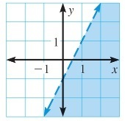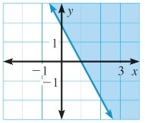
$\begin{aligned}y=3x−1 \\ y=−x+3\end{aligned}$ $\begin{aligned}y=−2x+1 \\ y=\frac{1}{2}x+6\end{aligned}$

Solution @ __________ Solution @ __________

$x=$________ $x=$________ $x=$________

$y=$________ $y=$________ $y=$________

$\begin{aligned}y<−2x−1 \\ y≥2x+3\end{aligned}$ $\begin{aligned}y≤−2x+5 \\ y>\frac{1}{4}x−2\end{aligned}$

Concept 4.4
Girl Scout cookies are being sold for $12 per box for Thin Mints (T) and $10 per box for Caramel DeLites (C). A total of 80 boxes were sold for a total of $830.

- Use the variables T and C, set up an equation for the number of boxes sold: _____________________

- Use the variables T and C, set up an equation for the amount of money made: _____________________

- Solve the system of equations for the values of T and C. T = __________ C = __________

Concept 5.1
Directions: Fully simplify the following expressions. Solutions may not have any negative exponents.
$x^{7}⋅x^{2}=$ _______ $(3x^{4})^{2}=$_______ $\frac{8x}{4x^{3}}=$ _______ $x^{0}=$ _______ $5x^{3}⋅3x^{2}=$_______ $\frac{5x^{2}}{\text{20}x^{−4}}=$_______
Concept 5.2
Directions: Add, subtract, multiply or divide the following polynomial expressions to fully simplify them.

$(4x^{2}+6x)−(2x^{2}−2x−6)=$_______________________ $\frac{2{\text{xy}}^{4}}{6x^{2}y^{−3}}=$_______ $(3x+1)(x−4)=$______________

